7) Capture video from web Camera and Display the video, in slow motion and in fast motion. operations on the captured video
PROGRAM
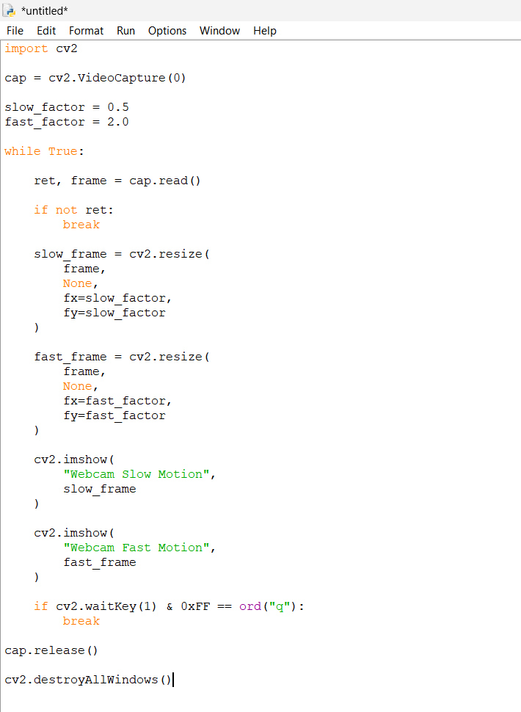

Output
